Face sheet download and upload process from Planner (OneDrive).
Step: 1
- Need to login to the Onedrive website: https://netorg393890-my.sharepoint.com/personal/joy_accesspsychology_org/_layouts/15/onedrive.aspx?id=%2Fpersonal%2Fjoy%5Faccesspsychology%5Forg%2FDocuments%2FAccess%20Facility%20Spreadsheets3
- Once get into the login, need to enter your username name.
Username | Password
billing@accesspsychology.org | MedUsabilling1@access

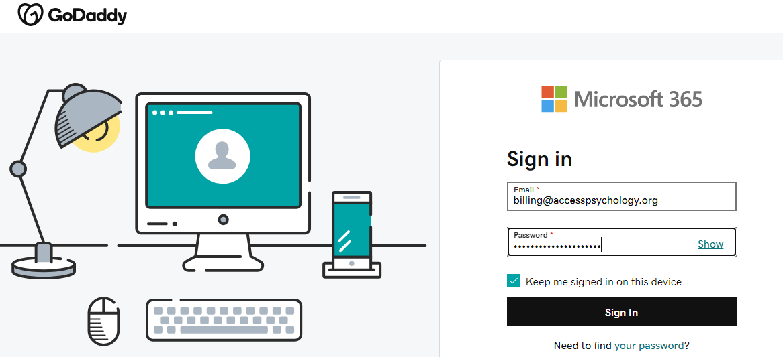

- It will request for MFA, Google Authenticator – Code request screen will populate.
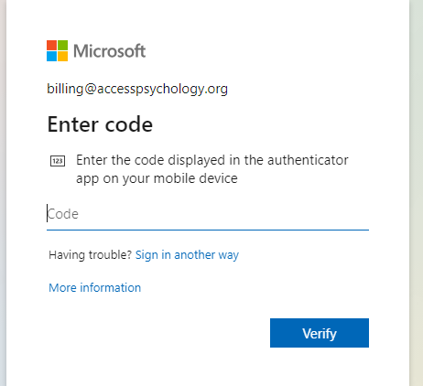

Step: 2
- Now we need to open the “Microsoft Edge” browser from the “Authenticator” icon need to select/copy the code
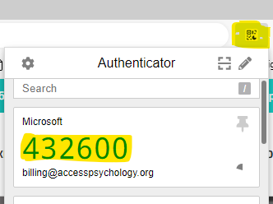

Step 3:
- After the above Google Authenticator verification is completed the below Dashboard will appear in which we need to Click the “Highlighted – Top of the left corner” Icon
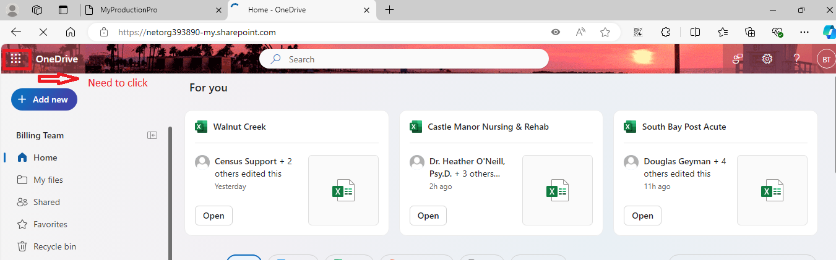

Step 4:
- After that, the below Dashboard will appear in which we need to Click the “Planner” Icon
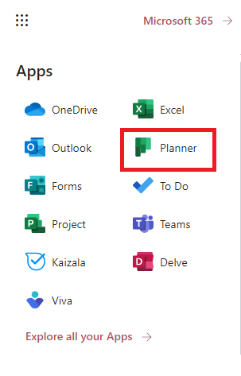

Step 5:
Click In My Plans:
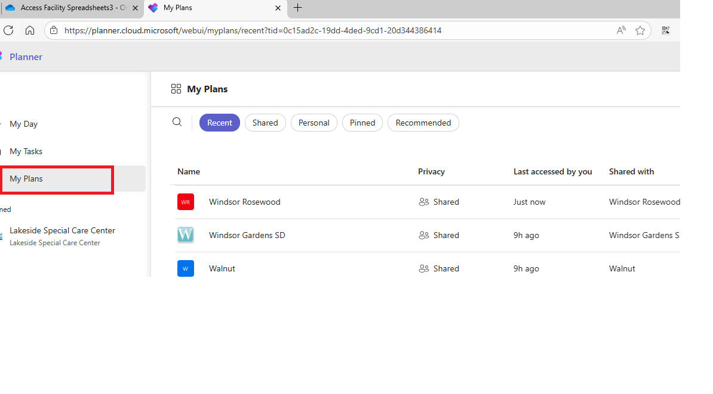
Please see the screenshot below. We need to select the facility name there, and the corresponding files will then be reflected in OneDrive.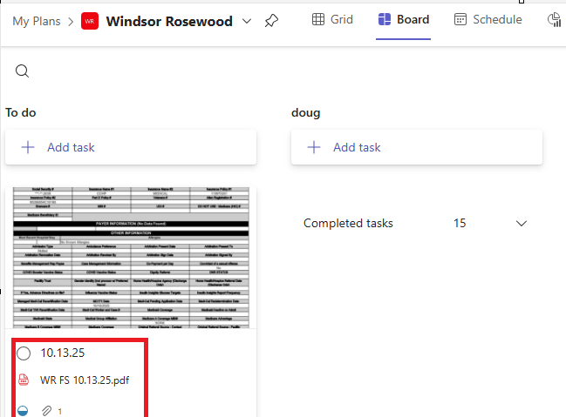

When we click on the files, the screen below will open. We then need to download the attachment files and set the process in the In-Process screen.

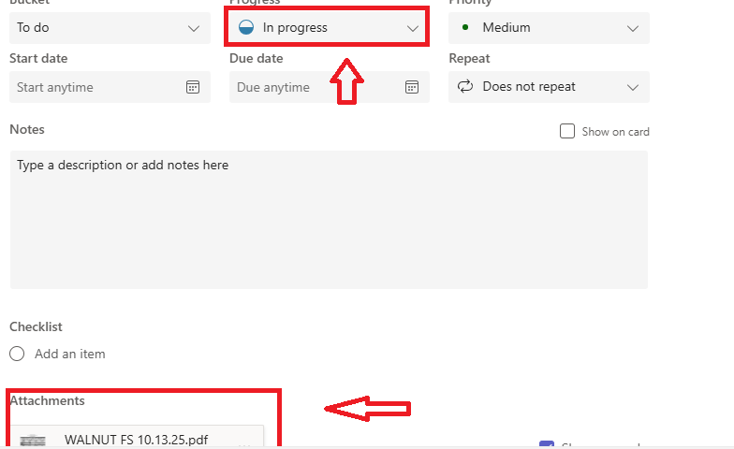
To upload the details to OneDrive, once the files are fully completed, we need to:
- Select the facility name.
- Click on the file name.
- On the screen that opens, mark the file as Completed if it is fully done.
- If the file is pending for secondary or requires any other clarification, select In-Process in OneDrive.
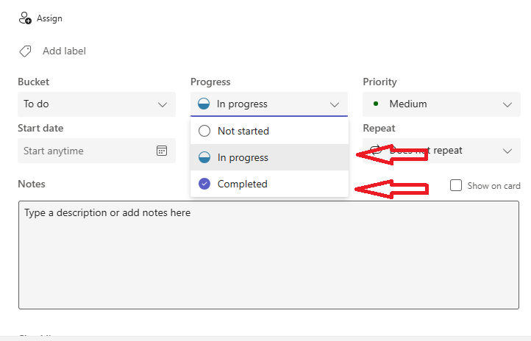

Thank you!

